**Lab: Installing DB on EC2**

**Services Used: EC2, Database [Any of the Supported]**

**Introduction:** In this Lab we are performing Database installation on an EC2 instance. This is the traditional database install method. After installation we connect to the database instance locally and remotely and add some data to it. In this example we will be using mariadb as the database and installation on a Linux EC2.

In real-time secured production environment, database will always be installed and configured in Private subnet.

1. Verify there are available private subnets in the VPC for building the new server. If not available configure new one.

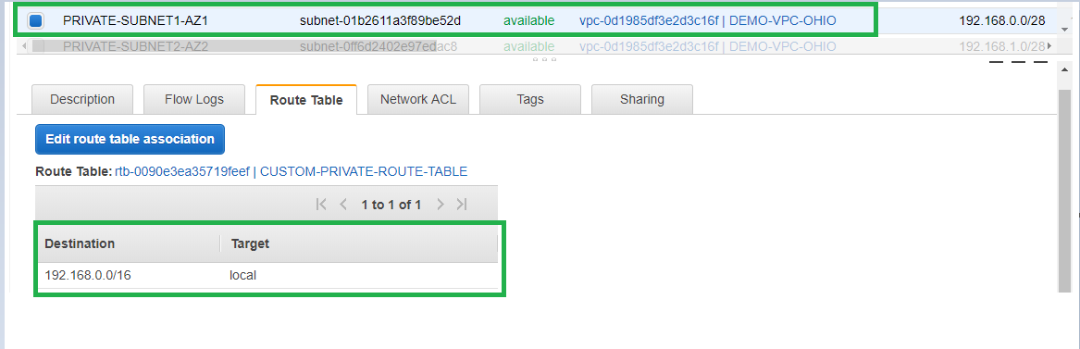

1. Launch a Linux based EC2 instance in the above mentioned private subnet. [Refer EC2 document for any doubts.
2. The security group of the DB instance should allow Ssh traffic from bastion host [Refer bastion server documentation] and DB traffic from the App server. Below is an example where inbound Ssh traffic allowed from bastion security group and DB traffic allowed from app server security group. All outbound traffic is allowed.

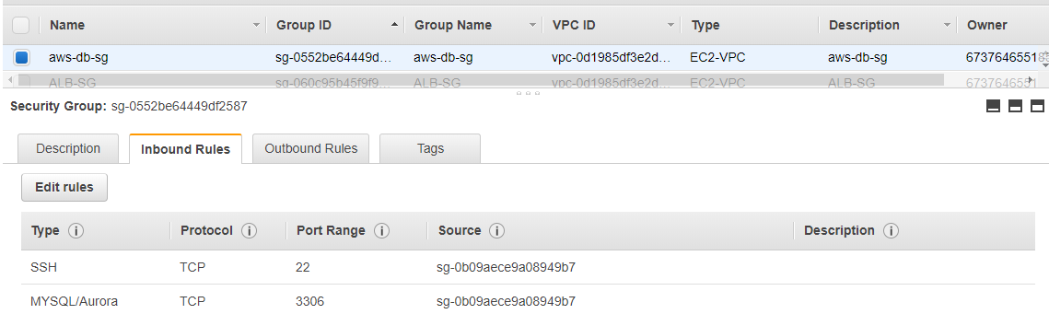

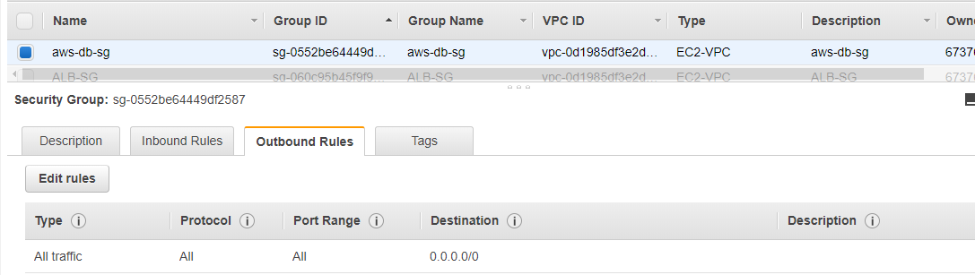

1. The DB instance launch is successful in the private subnet with db security group. Now we can login and perform the database installation.

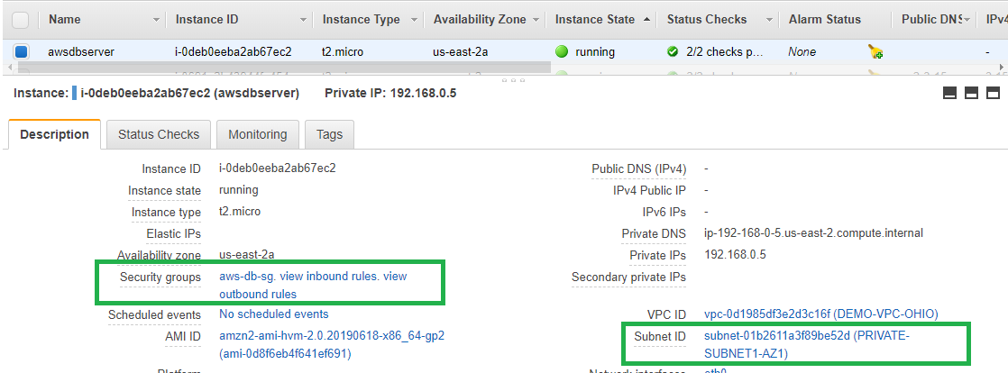

1. The SSH login from our bastion host to the newly built db server is successful.

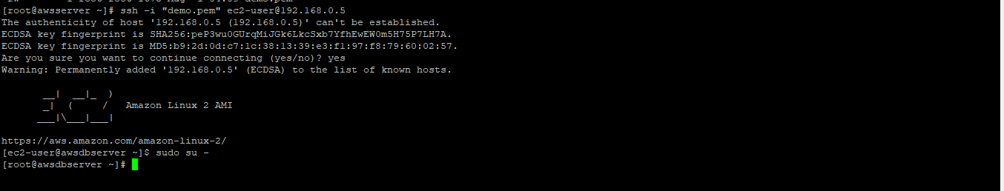

1. It is always recommended to update the OS packages prior the db installation. For this demo NAT instance is already configured so that this db instance on private subnet can download packages. Refer the NAT instance document for more details.
2. Run yum update –y and complete the update if any available.
3. Proceed to install mariadb. Run command “yum -y install mariadb-server” to start the install.

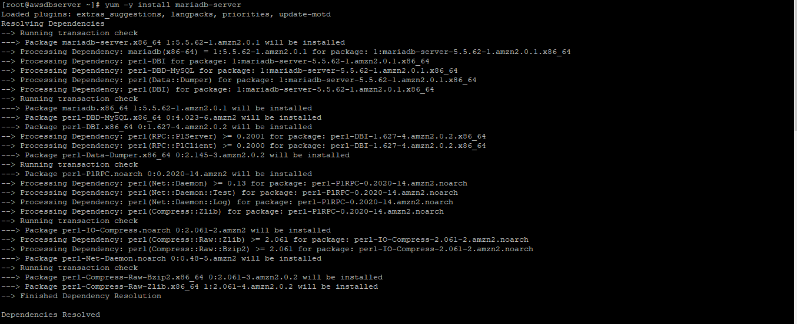

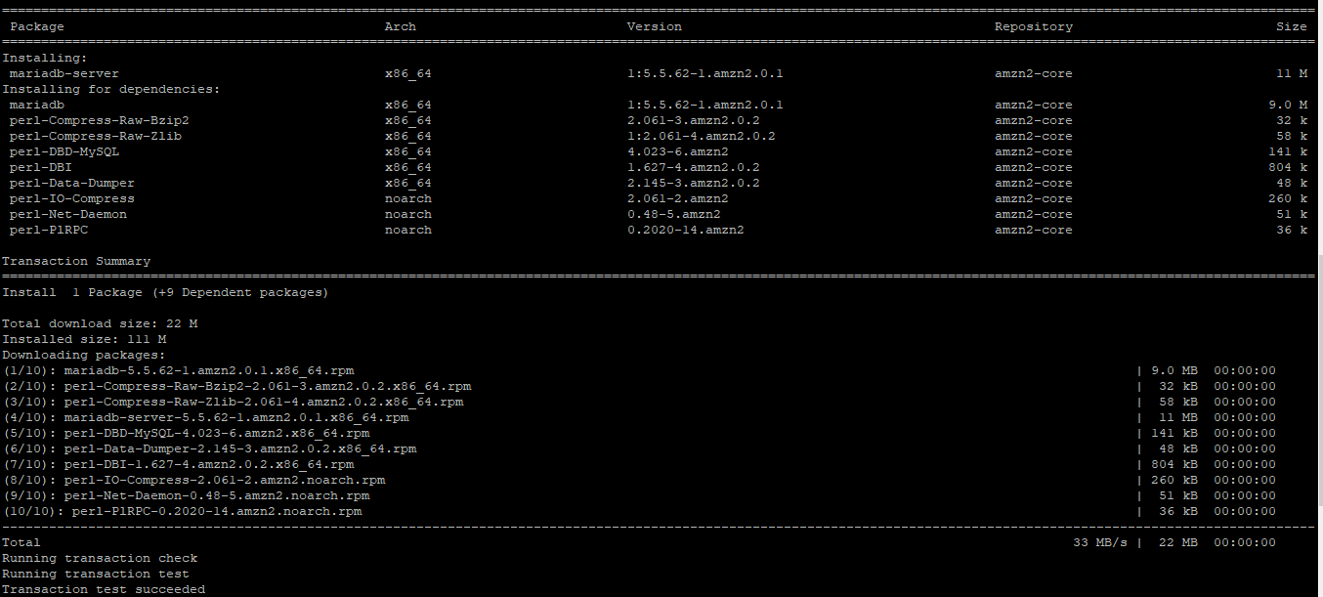

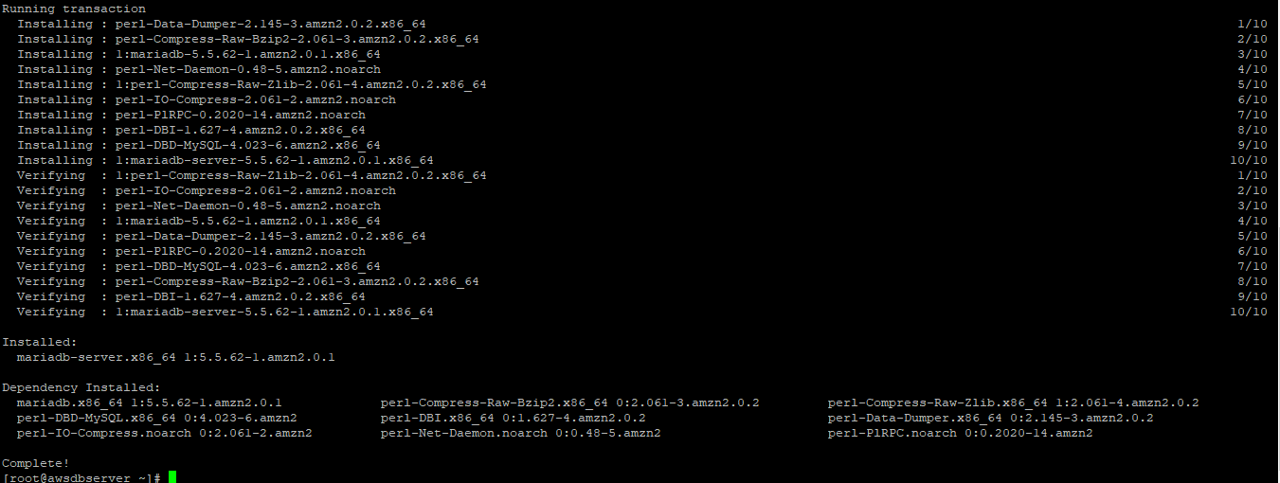

1. Verify the database is installed.



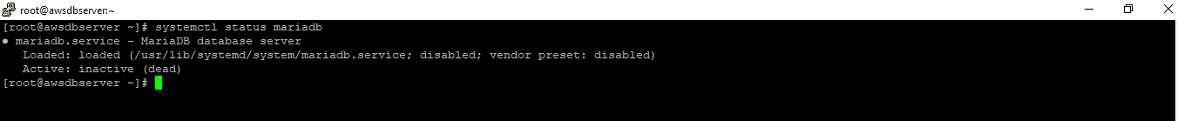

1. Enable and start the db service.

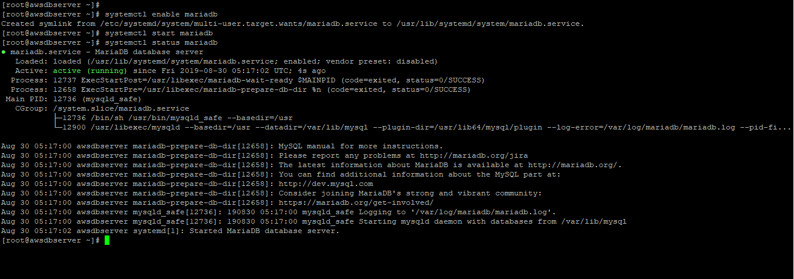

1. Connect to the db instance first time using root user and empty password. Localhost with –h refers to connect to the same server. If you are connecting from a remote server use the db server ip with –h option.

Change password by running mysqladmin command.

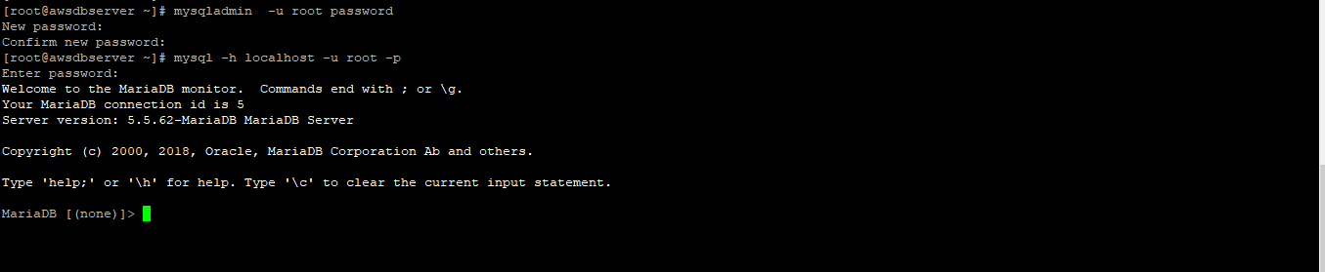

1. Create new admin user for db management.



1. Reconnect using the newly created admin user.

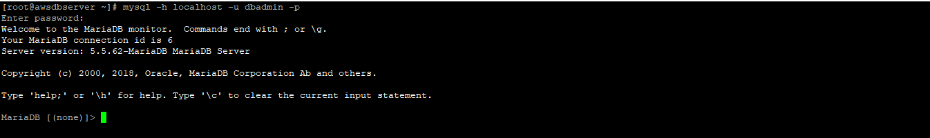

1. Create database, table, add data and query data.

